Critical Items:
• Hire a Forescout Engineer that can not only manage the care and feeding, but also advance the maturity and use cases
o Or provide Staff Augmentation via Forescout or one of our partner's professional services
• Utilize remaining PS hours provided at no cost by Forescout
• Validate that every CVS network/subnet (wired/wireless/VPN) was defined and up to date in Forescout
  - This work was performed earlier in the year by Luis, but he was let go prior to validation
- Validate that every L2/L3 network device and all wireless controllers are defined and up to date in Forescout
  - We need a network resource to validate that we have ALL production switches added to Forescout and that they are configured correctly
    - SNMP read-write
    - SNMP linkup/linkdown & MAC notification traps
• Define simple and achievable device compliance that does not require cross-functional collaboration (leveraging the visibility we have today).
o Examples to include:
§ Windows Devices – Must have SecureConnector, CrowdStrike installed and running, encrypted, and no Peer to Peer.
§ Printers – Can only be specific make/models (Brother printer XXX or HP printer YYY)
§ MacOS - Must have CrowdStrike Installed and running, encrypted, and no Peer to Peer.
§ Cameras - Can only be make/models: XXX, no telnet, HTTPS only.

I also spent some time with Aaron after our call yesterdaya and grabbed some screenshots to put the below “current state” together. I broke this out to cover the current state, and a phased approach to next steps. Before we dive into that, I wanted to cover the way that devices come online with Forescout so that the information following will make more sense. Here is a workflow using your current deployment as an example:

- A new Windows device connects to the network
- The switch notifies Forescout that a new device has connected to it
- Forescout queries the ARP table and gets an IP-MAC binding, creates an entry for the device, and uses several techniques to properly classify the device
- That device then flows through a “Discovery” policy, which in this example, it would waterfall through to “Windows"
  - 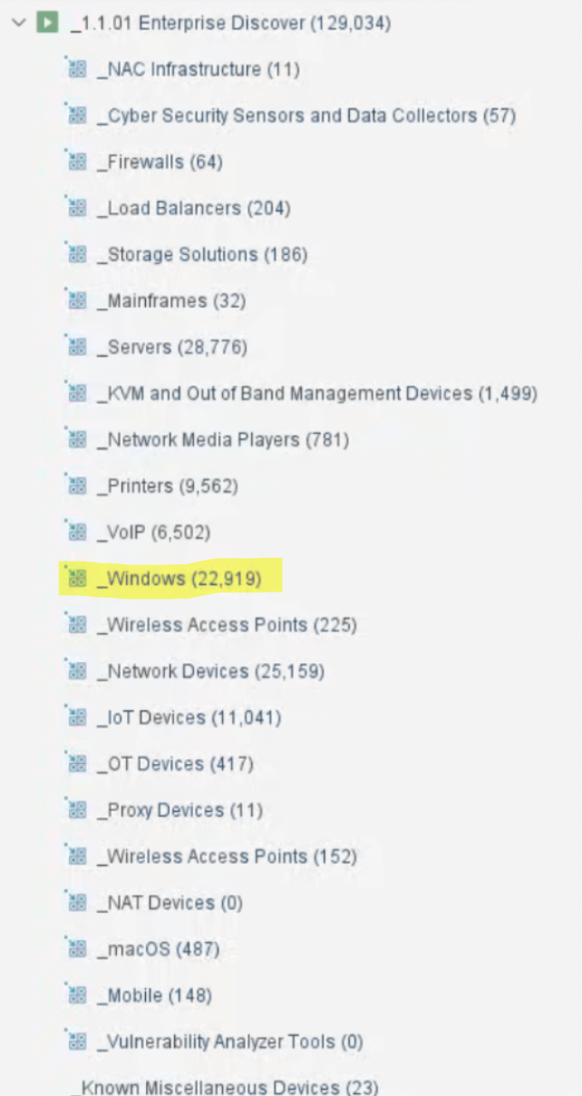
- Now that we’ve identified it as a Windows device, we then move it along to an assessment policy to determine whether it should be on the internal network or not (is it a CVS asset?)
- Here is the “Windows Enterprise Manageability” policy, where a Windows device is determined to be either fully trusted, semi-trusted, or untrusted
  - 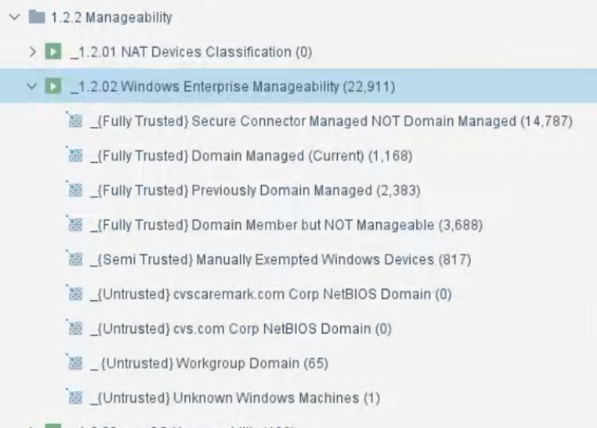
- If a device is found to be untrusted, then network access is blocked/restricted. If it is deemed a trusted asset, then it is granted network access and moved along to a posture/compliance set of policies
- Today, CVS is checking for AV, disk encryption, cloud storage, P2P, IM, and blacklisted applications:
  - 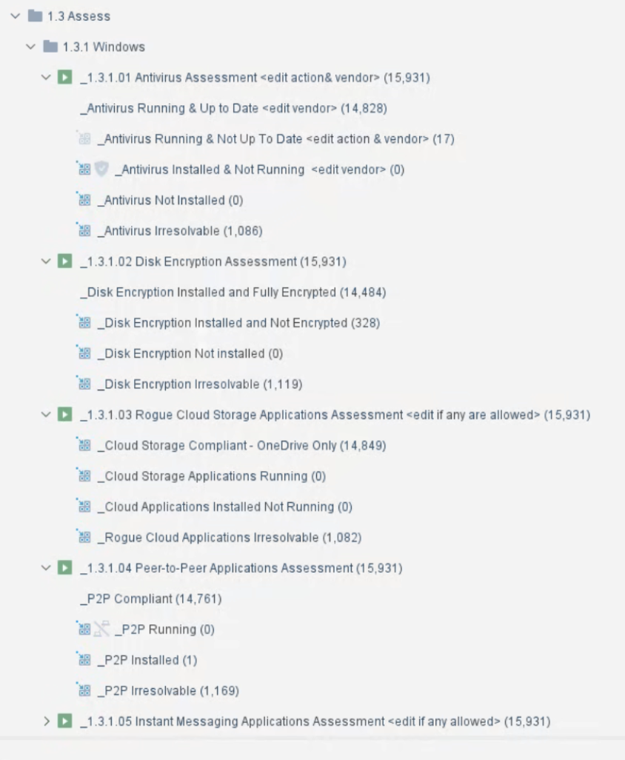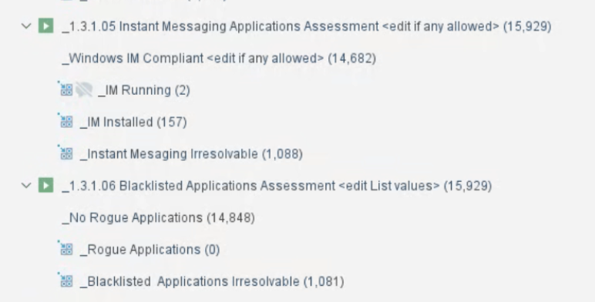
- If a device is found to be compliant on all these items, nothing happens. However, if any of these work streams fails compliance, then we move the device through to a control or remediation policy.
  - A remediation policy can do anything from triggering an SCCM/MDM update, killing a process/service, or even running a script on the local device
  - A control policy can be anything from an ACL written to the switchport, a VLAN change, or added to a firewall group to restrict at the edge.

There are work streams like the one above for each type of device, so a device will connect, get classified, get authorized, and then be checked for compliance. The outcome of each individual work stream will inevitably determine what control/remediation (if any) are needed. There are separate work streams for Windows devices, printers, cameras, MacOS, IoT, etc., that all lead to the same outcome. Those compliance and posture assessments are done after authorization and would be where we would utilize the pulled data from CrowdStrike, Intune, Qualys, etc. to execute a control/remediation action if required, which is the piece that is missing today. So, at a high-level, a connecting device goes through the following workflow upon EVERY admission event, and with the agent, must maintain real-time compliance or risk having a control put in place:

Connectivity —> Discovered —> Classified —> Authorized —> Posture/Compliance —> Control/Remediation (if needed)

Now, moving forward we have a few items that need to be addressed so that we can make sure that we have complete visibility into the network, are able to properly assess each connected device, and enrich the above compliance policies. I have broken these items out into 3 buckets; critical, policy/procedure, and integrations.

Critical Items:
- Validate that every CVS network/subnet (wired/wireless/VPN) are defined and up to date in Forescout
- Validate that every L2/L3 network device and all wireless controllers are defined and up to date in Forescout
- Hire a Forescout admin that can not only manage the care and feeding, but also advance the maturity and use cases
- Get Aaron through FSCA training
- Utilize remaining PS hours

Policy/Procedure:
- Define authorization/assessment criteria for non-Windows/MacOS devices such as printers, cameras, IoT, etc.
  - Is it in CMDB?
  - Is it in Intune/JAMF?
  - Is it managed by another system?
  - Does it have a corporate SNMP string or user/pass?
- Workflows to provide to device owners to onboard their devices
  - If we’re blocking unknown devices at the beginning, then users will need a process in place to follow to get approval and onboard their devices
- If desired, define “compliance” criteria for each device type (printers, cameras, IoT, etc)
  - Anything about what the actual devices should have installed and should or should not be doing/running can be defined here

Integrations
- CrowdStrike
  - Forescout’s device discovery along with CrowdStrike’s endpoint intelligence provides a complete view of managed, unmanaged, and rogue devices
  - Automatically validate CrowdStrike agent presence and health, and trigger enforcement actions in Forescout if devices are non-compliant
  - Share CrowdStrike threat detections with Forescout for faster threat response, and quickly isolate compromised devices from the network and contain attacks
  - Enforce security policies and streamline compliance by ensuring only CrowdStrike-protected and compliant devices maintain network access
- Intune/JAMF
  - Correlate JAMF/Intune mobile and endpoint compliance data with Forescout’s real-time network discovery for full device profile and visibility
  - Continuously validate device enrollment and compliance status from Intune/JAMF for stronger security posture, and enforce controls in Forescout if devices fall out of policy
  - Automatically restrict or quarantine unmanaged, non-compliant, or unregistered devices from the network for faster risk response
  - Ensure only Intune-registered and policy-compliant devices gain or retain access to corporate resources
- Qualys
  - Enrich Forescout’s real-time device inventory with Qualys vulnerability and configuration assessment data
  - Correlate vulnerability insights from Qualys with Forescout policies to identify and control high-risk devices on the network
  - Automate enforcement actions (restrict, segment, or quarantine) on vulnerable or non-compliant devices before they can be exploited
  - Support regulatory and internal audits by ensuring devices meet patch, configuration, and vulnerability management requirements
- ServiceNow
  - Enrich the CMDB with real-time, agentless device data from Forescout to ensure accurate and up-to-date asset inventories
  - Correlate Forescout’s device and compliance data with ServiceNow’s ITSM/SecOps workflows for better incident prioritization
  - Automatically create, update, and route ServiceNow tickets when Forescout detects policy violations or security issues
  - Improve audit readiness by maintaining accurate device records and linking Forescout detections directly into governance workflows
- Splunk
  - Stream Forescout’s real-time device and network context into Splunk for a more complete security and operations view
  - Correlate Forescout’s device compliance and posture data with Splunk’s log and event data to detect risks faster
  - Trigger automated actions in Forescout from Splunk playbooks (SOAR) to isolate or remediate compromised devices
  - Centralize reporting by combining Forescout’s device intelligence with Splunk dashboards to meet audit and regulatory requirements
- Palo Alto
  - Share Forescout’s device identity and posture data with Palo Alto NGFWs to improve policy granularity and traffic control
  - Enforce dynamic access policies on the firewall based on device compliance, user identity, and risk level
  - Automatically trigger segmentation or blocking actions on Palo Alto NGFWs when Forescout detects compromised or rogue devices
  - Align firewall enforcement with security policies by ensuring only compliant and authorized devices can access critical applications

All the above items, when put together, can automate onboarding, authenticating, authorizing, and validating compliance and risk of every connected device on your network. Forescout can orchestrate between all these technologies to make sure that every device is meeting, and maintaining, the compliance and risk posture that is required by CVS.

I know that this is a lot of information to unpack, so please don’t hesitate to reach out with any questions, or we can go through this live on a call in your Forescout console so that you can see how things flow through.

